**Massachusetts Executive Office of Public Safety and Security**



**Statewide Applicant Fingerprint Identification Services** **(SAFIS) Program**

Registration Guide

**Massachusetts Department of Developmental Services (DDS)**

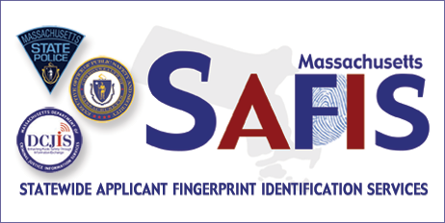

Contents

About the Statewide Applicant Fingerprint Identification Services (SAFIS) Program 3

Overview of the Fingerprinting Process 3

Important Requirements 4

Registering with MorphoTrust USA for a Fingerprinting Appointment 5

MorphoTrust USA IdentoGO™ Massachusetts Registration Website 5

Registering Online 5

Registering by Phone 20

Rescheduling an Appointment 20

Cancelling an Appointment 22

Missed Appointments 22

Rejection Notification 22

Acceptable Forms of Identification 25

Primary Identification Documents 25

Applicants Under 18 Years of Age 25

Fingerprint Appointment 26

Contacting Customer Service 27

# About the Statewide Applicant Fingerprint Identification Services (SAFIS) Program

Massachusetts Law and Federal Law require the Department of Developmental Services (DDS) to fingerprint persons who support individuals with intellectual/developmental disability in DDS-licensed, funded, or approved services, or who are otherwise required to receive a fingerprint-based check of the state and national criminal history databases in accordance with General Law c. 19B, §§ 19-20. DDS has partnered with the Executive Office of Public Safety and Security (EOPSS) and MorphoTrust USA to use the Statewide Applicant Fingerprint Identification Services (SAFIS) program to take fingerprints for all current and prospective employees of DDS and DDS-contracted vendor programs licensed, funded, or approved by DDS, or any other person required by General Law c. 19B, §§ 19- 20 and Department regulations (115 CMR 12.00) to undergo fingerprint-based checks. This program was established by EOPSS in partnership with the Department of Criminal Justice Information Services (DCJIS) and Massachusetts State Police (MSP), to support **non-criminal justice** fingerprint based state and national criminal history record information (CHRI) checks. This program has convenient applicant fingerprinting enrollment centers throughout the Commonwealth of Massachusetts. Applicants must register for an appointment via the IdentoGO™ by MorphoTrust USA registration system. Fingerprints are captured and submitted electronically for processing by the MSP and Federal Bureau of Investigation (FBI). State and national CHRI results are disseminated to authorized organizations by the DCJIS.

## Overview of the Fingerprinting Process

The following is an overview of the SAFIS fingerprinting process:

* Upon receipt of notification from DDS an applicant registers for a fingerprinting appointment via either the MorphoTrust USA IdentoGO™ registration website or the MorphoTrust Massachusetts Customer Service (telephone) Center;
* An applicant goes to a MorphoTrust USA IdentoGO™ enrollment center on the date and time selected by him/her and has his/her fingerprints taken;
* The applicant’s fingerprints are sent electronically to the Massachusetts State Police (MSP) for a statewide criminal history record check and to the Federal Bureau of Investigation (FBI) for a nationwide criminal record check;
* The results of both the State and National fingerprint-based criminal history record checks are returned to the MSP; and
* The State and National fingerprint-based criminal history record check results are returned to DDS for review. DDS will then determine if the applicant is suitable or not suitable for the position sought.

# Important Requirements

**1**

**Information Required at Registration**

To register for an appointment to have your fingerprints taken at one of the MorphoTrust USA IdentoGO™ enrollment centers, the following information is required:

**DDS Person Identification Number -** DDS will provide you with your DDS Person Identification Number once you have been CORI-cleared following a Criminal Offender Record Information (CORI) check pursuant to 101 CMR 15.00 and a fingerprint-based check has been requested by your hiring authority.

**2**

**Your Registration Confirmation and an Acceptable Form of Identification are Required at Your Fingerprint Appointment**

You must bring your **Registration Confirmation Number** with you to your fingerprinting appointment. You must also bring an acceptable form of identification (see page 25). The MorphoTrust USA IdentoGO™ enrollment center staff will match the information in the registration system with the identification provided to confirm your identity. **Fingerprints will not be taken without acceptable form of identification.**

# Registering with MorphoTrust USA for a Fingerprinting Appointment

To get your fingerprints taken, you must register for an appointment. There are two methods available: 1). Register on-line on the MorphoTrust USA IdentoGO™ registration website; or 2). Register by phone.

## MorphoTrust USA IdentoGO™ Massachusetts Registration Website

* Go to <http://www.identogo.com/FP/Massachusetts.aspx>
* Click the **Online Scheduling** link.
* To see a complete list of MorphoTrust USA IdentoGO™ enrollment centers in Massachusetts, click on the **Locations** link.
* To access online resources, click on **Forms and Links**

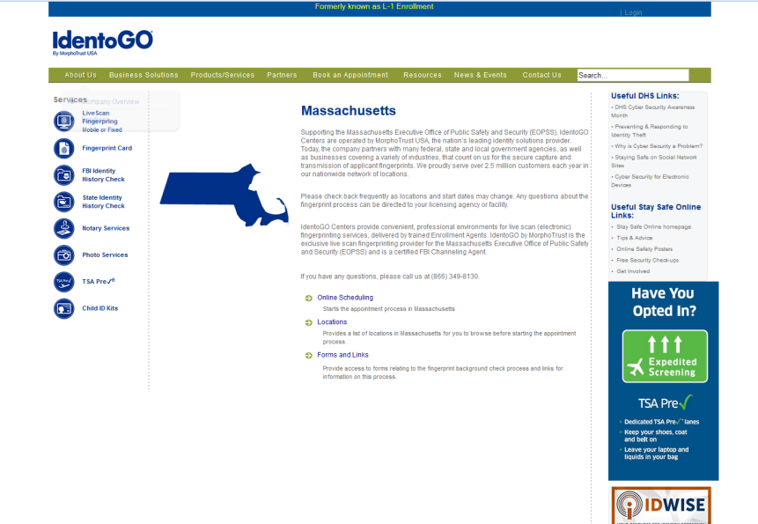

## Registering Online

To begin the registration process:

* Go to <http://www.identogo.com/FP/Massachusetts.aspx>
* Click the **Online Scheduling** link.

|  |
| --- |
| APPLICATION DETAILS |

* Enter **First Name** and **Last Name**.

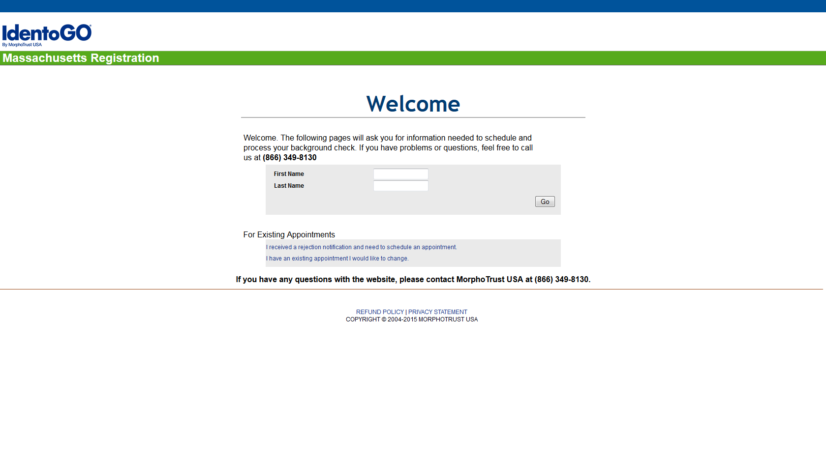

* Click the **Go** button on the page.
* In the Agency/Sector drop-down list, Select **Department of Developmental Services (DDS)**.
* Click **Go**

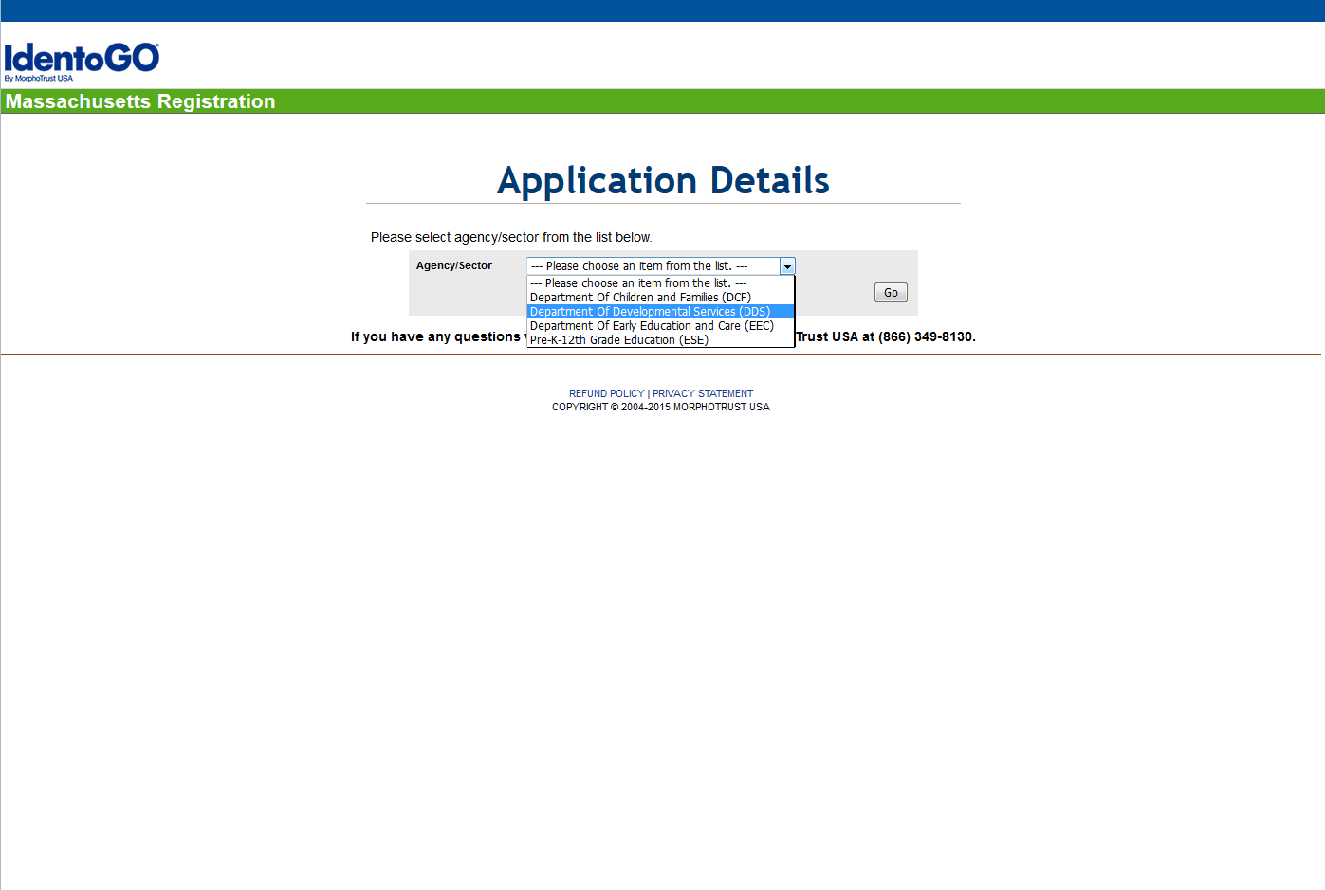

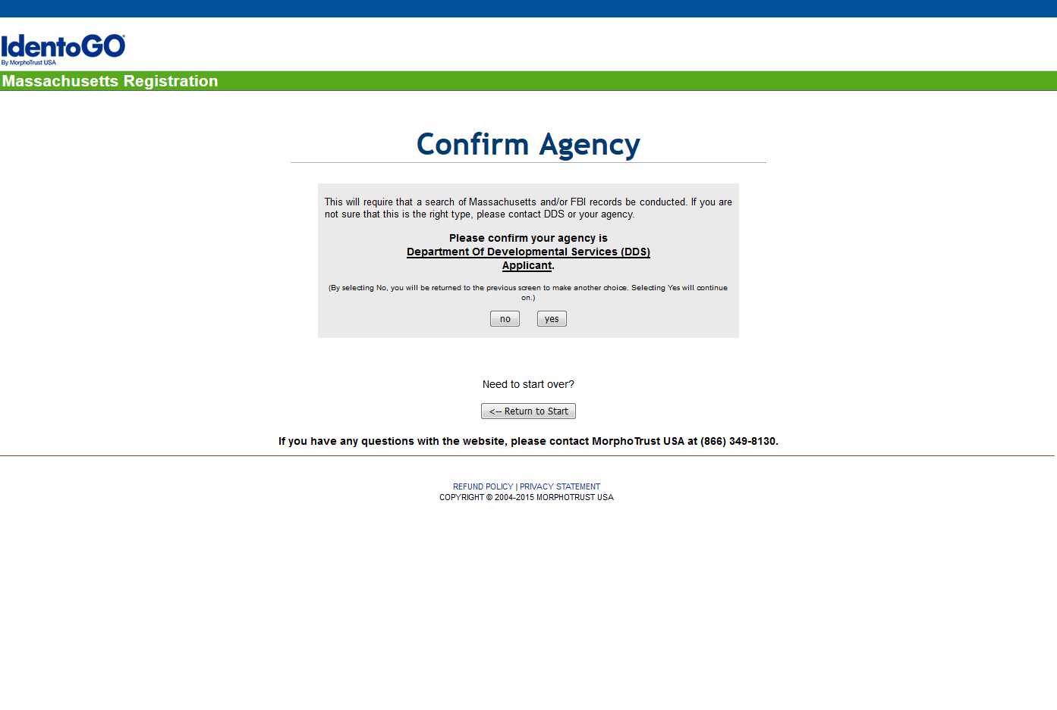

* Based on your Applicant Type selection, Click **Yes** to confirm your Agency as the Department of Developmental Services (DDS).
* Enter the **DDS Person ID** (**PID**) you obtained from DDS and your **Date of Birth (DOB)** and click **Go**.

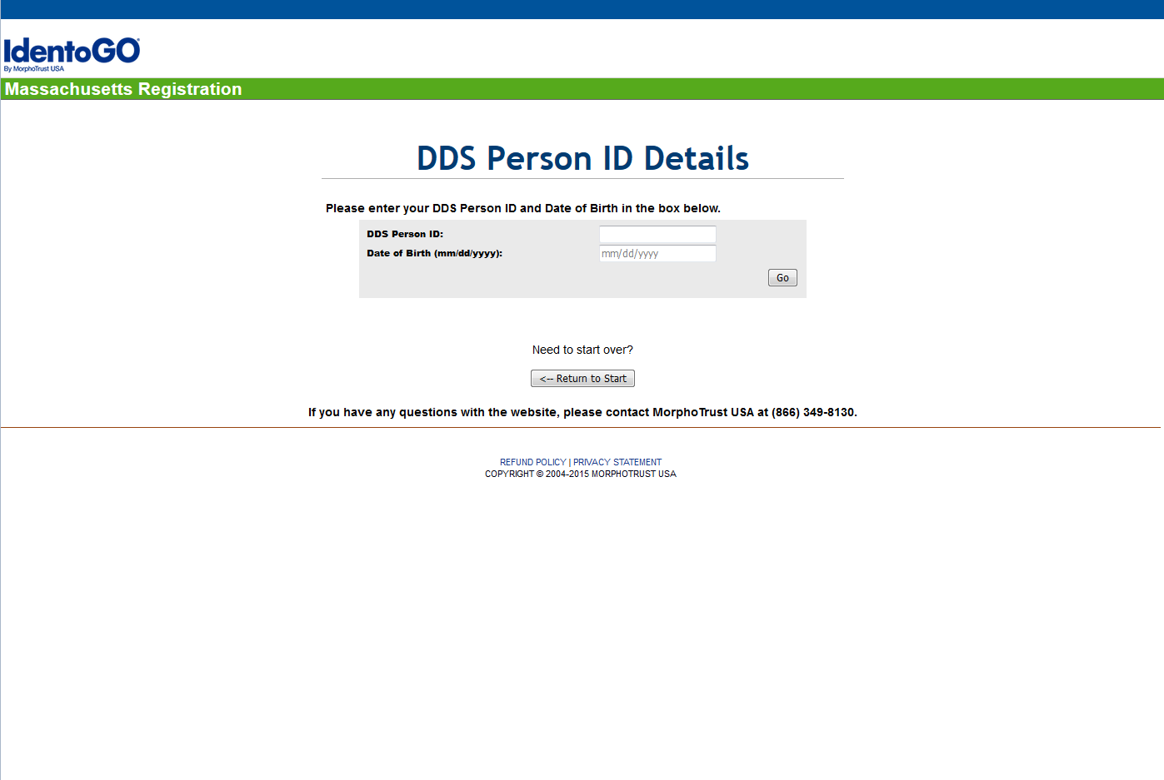

* The **First and Last Name** associated with the **DDS Person ID and DOB** you entered will be displayed. Please verify that the **First and Last Name** is correct.
* If correct, click the **Correct** button.

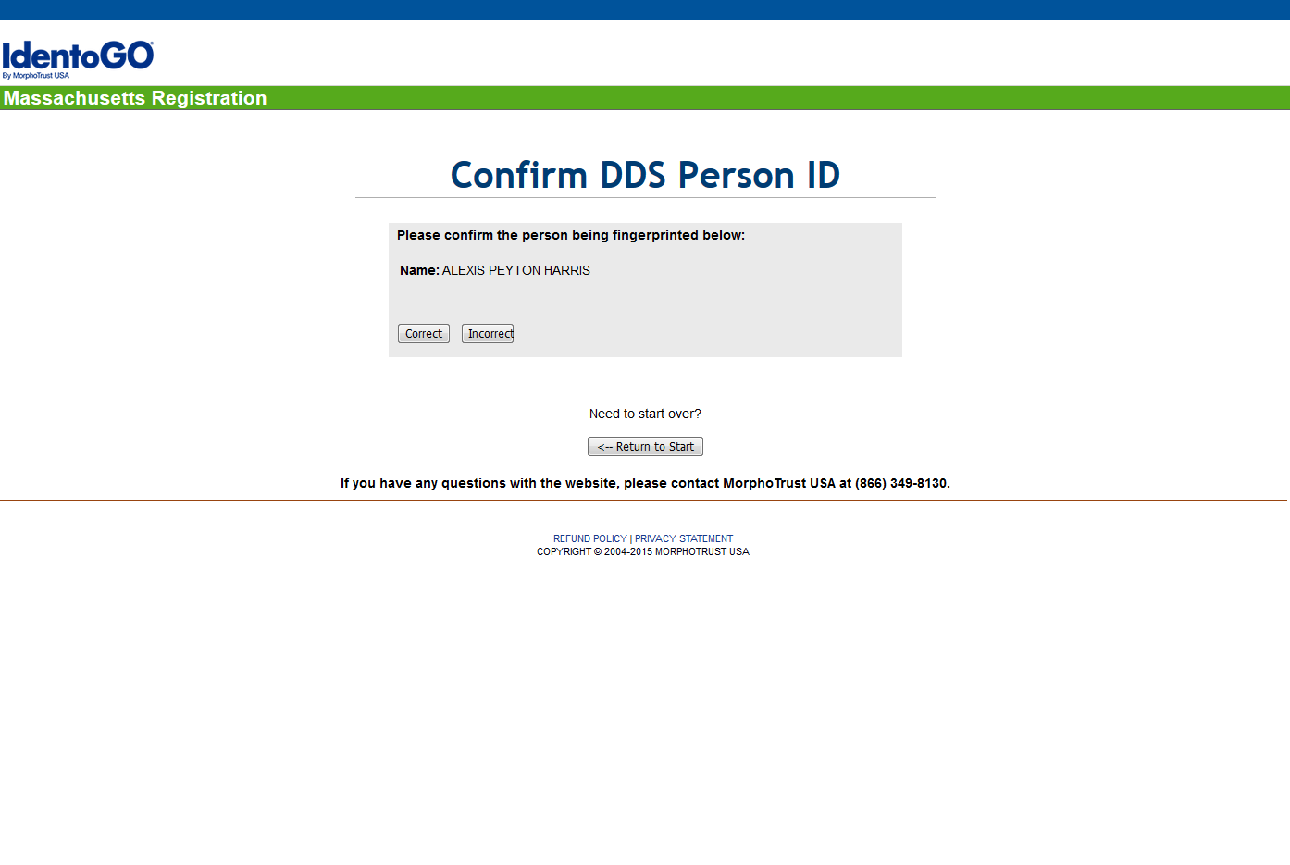

* If not correct, click the **Incorrect** button and reenter the **DDS Person ID and DOB**.

**NOTE:** If the First and Last Name displayed on the screen, does not match the DDS Person ID and DOB entered, please contact the DDS Criminal Background Check Unit at (617) 624-7780 to verify your DDS Person ID.

|  |
| --- |
| APPOINTMENT DETAILS |

* To find the location of the nearest MorphoTrust USA IdentoGO™ enrollment center, enter Zip Code in the box provided and click **Go.**
* To see a list of all MorphoTrust USA IdentoGO™ locations in a particular region of the state, select the region in the Region drop-down list and click **Go**.

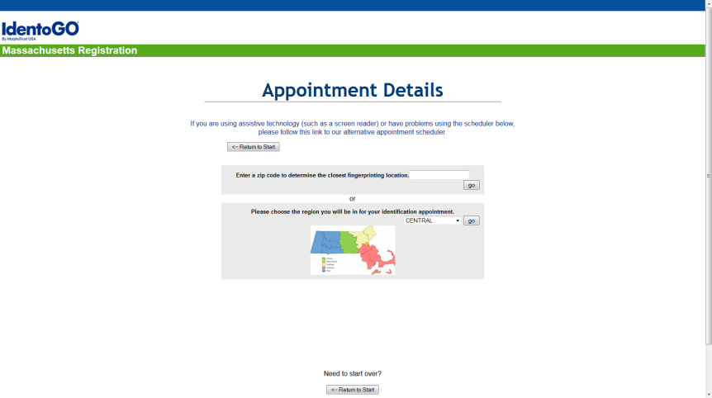

* Available appointments during the next seven (7) days will be presented.
* To view future dates, click the **Next Week** link.
* Click on the **Click to Schedule** link for the date and location you want.
* Select the preferred time.
* Click, **Go**.

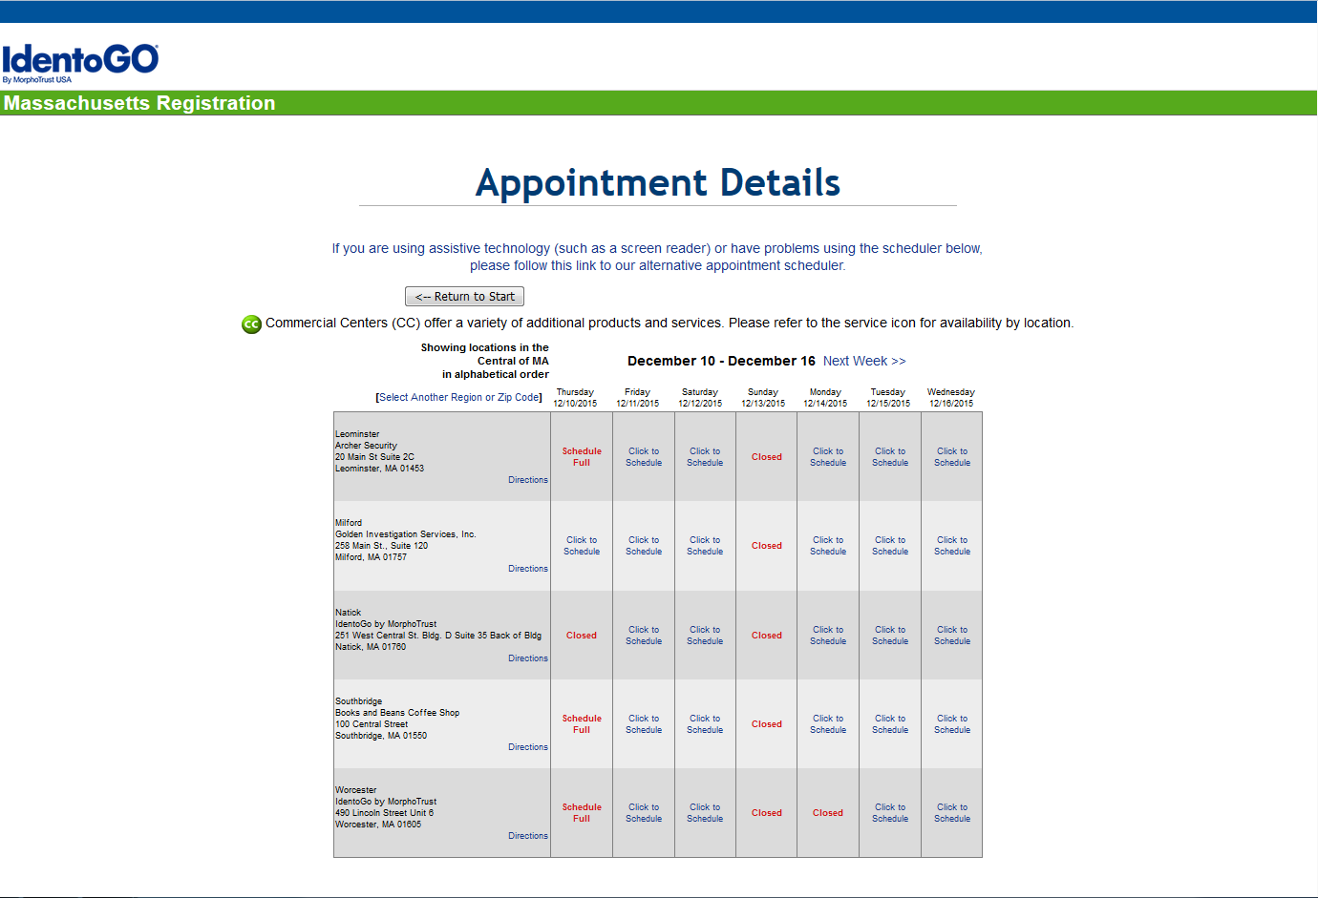

A consent form to authorize the fingerprint-based background check will be presented for review by the applicant.

* If you agree to the terms and conditions, select **I Affirm that I have read and fully understand the above and consent to the aforementioned background check**.
* If you do not agree to the Terms and Conditions, select **I DO NOT Agree to the terms and conditions of the Massachusetts background check** and the registration process will be cancelled.
* If the applicant is less than eighteen (18) years of age, a parent or legal guardian will also need to review and electronically provide consent.
  + Enter **First Name** and **Last Name** of the parent or legal guardian.
  + Select, **I Affirm that I have read and fully understand the above and consent to the aforementioned background check**.
* Click **Go**.

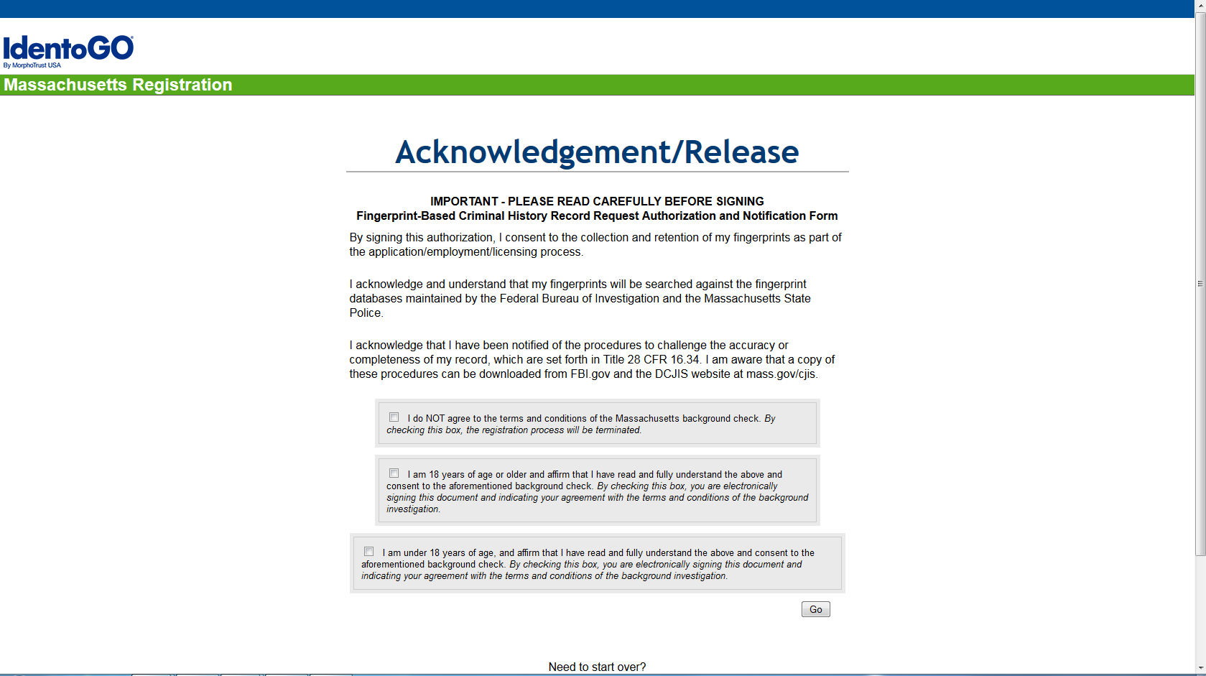

|  |
| --- |
| APPLICANT DETAILS |

* You will be required to provide standard demographic data, including Name, Date of Birth, Home Address, and Contact Information. Please note MSP and FBI require information such as gender, height, weight, race, hair, eye color, and place of birth.
* Enter the required information and click the **Send Information** button.

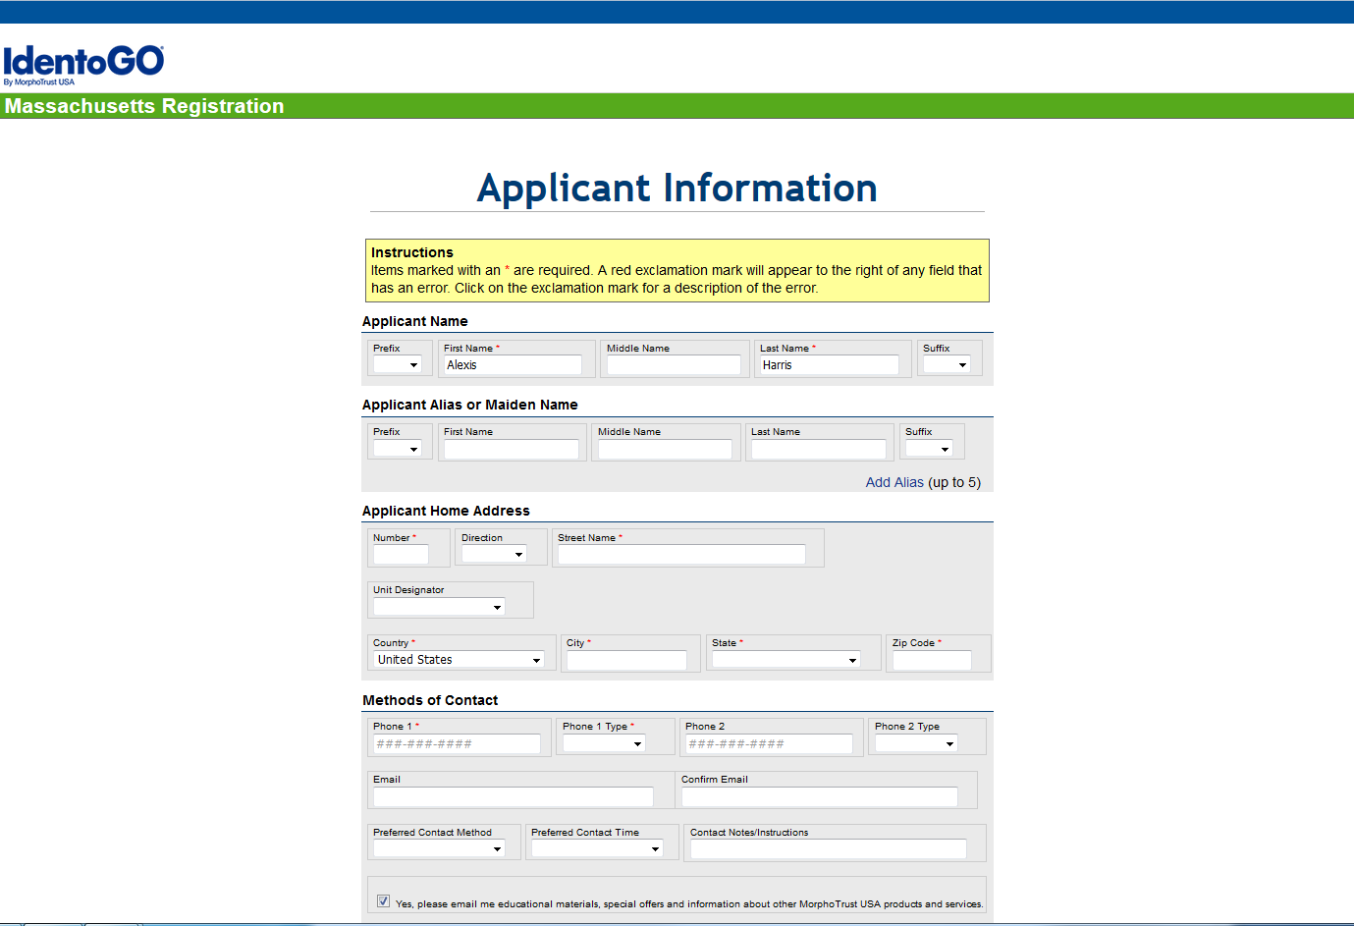

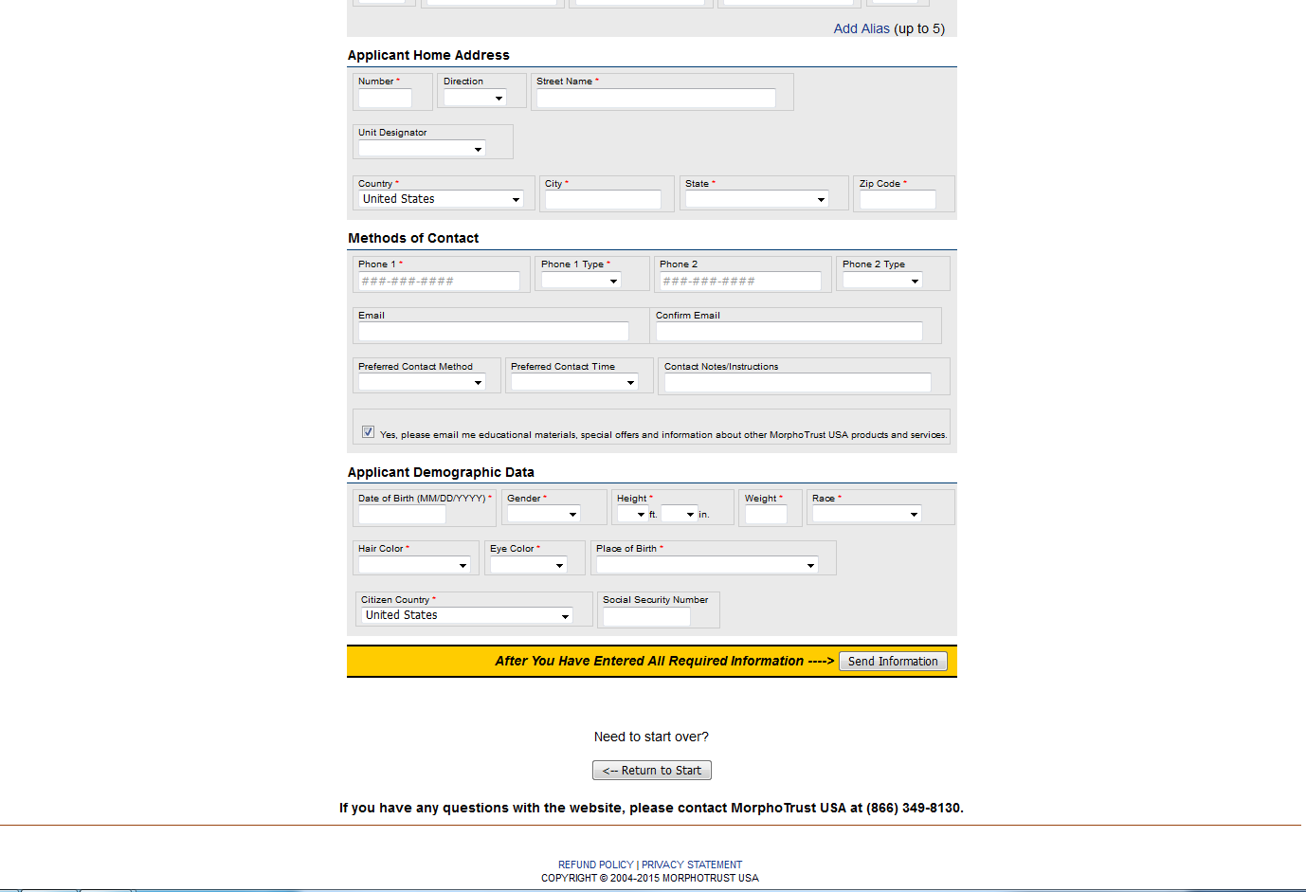

* You will then be required to verify the information provided for the registration process.

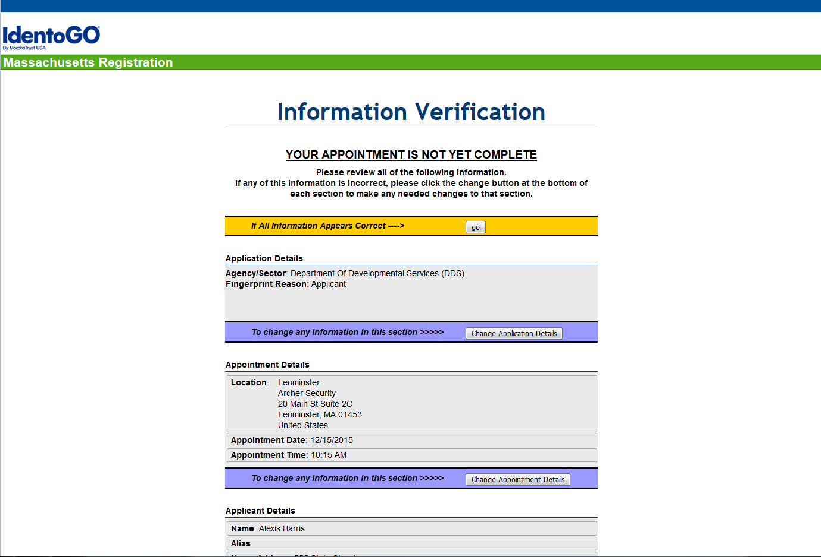

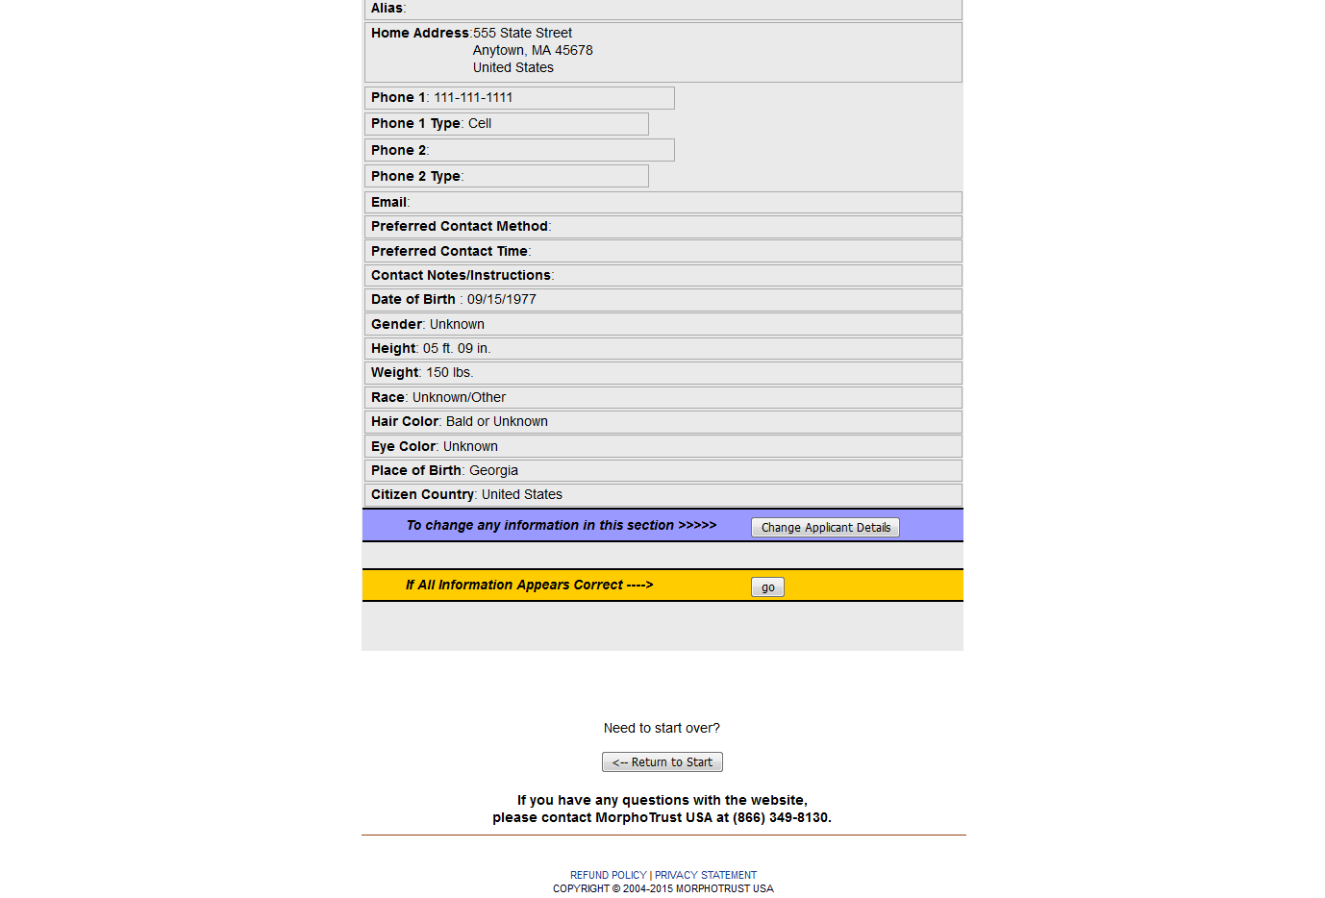

* If all of the information provided is correct, click the **GO** button at the top of the page.



* If any of the Application Details are incorrect, click the **Change Application Details** button.



* If any of the Appointment Details are incorrect, click the **Change Appointment Details** button.



* If any of the Applicant Details are incorrect, click the **Change Applicant Details** button.



|  |
| --- |
| PAYMENT |

* Select the **Method of Payment.**
* Click the **Send Payment Information** button.

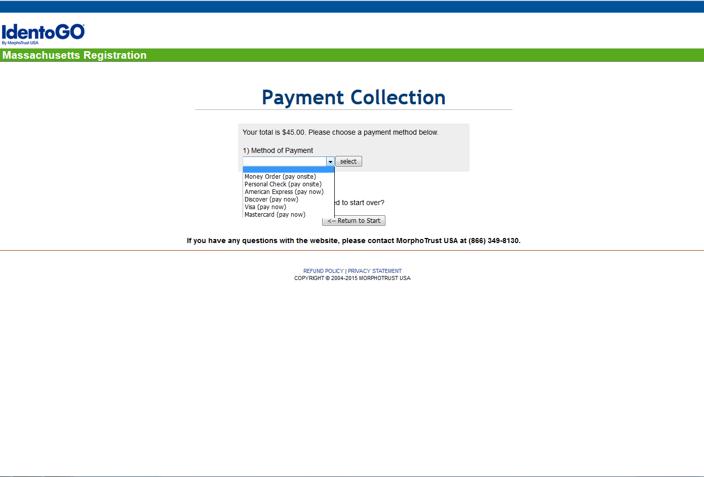

|  |
| --- |
| COMPLETE REGISTRATION |

* If Onsite Payment is selected, please bring a business check, personal check or money order in the exact amount with you to your appointment, along with an acceptable form of identification.
* If Online Payment is selected, click the **Continue to Make Payment** button. You will be routed to a secure e-Payment portal provided by MorphoTrust USA partner, US Bank. All payment information is collected on the US Bank e-Payment portal and only transaction reference numbers are provided to MorphoTrust USA by US Bank. The reference number is attached to the fingerprint appointment to ensure no collections will be required onsite.
* Print a copy of the **Registration Confirmation** and bring the Registration Confirmation with you to your appointment.

## Registering by Phone

Although online registration is the best way to register for a fingerprinting appointment, you may also register by calling the MorphoTrust Massachusetts Customer Service Center toll free at (866) 349-8130. You will be asked the same information as required by the online registration process, so please have all information available to provide to MorphoTrust Massachusetts Customer Service Representative. Please note you will be provided with a **Registration ID number**, so please be prepared to record this number for future reference.

# Rescheduling an Appointment

If you need to reschedule your fingerprinting appointment, you must do the following:

* Go to <http://www.identogo.com/FP/Massachusetts.aspx>
* Select **I have an existing appointment I would like to change** link at the bottom of the page.

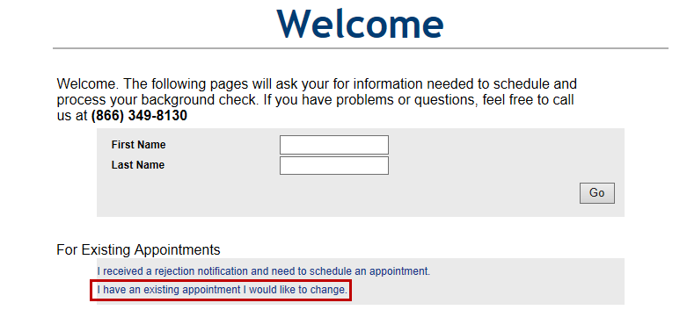

* Enter either your **email address** or your **Registration ID**. If you don’t have either or the website does not locate your record, please contact the MorphoTrust Massachusetts Customer Service Center at (866) 349-8130 for assistance.
* Click **Go**.

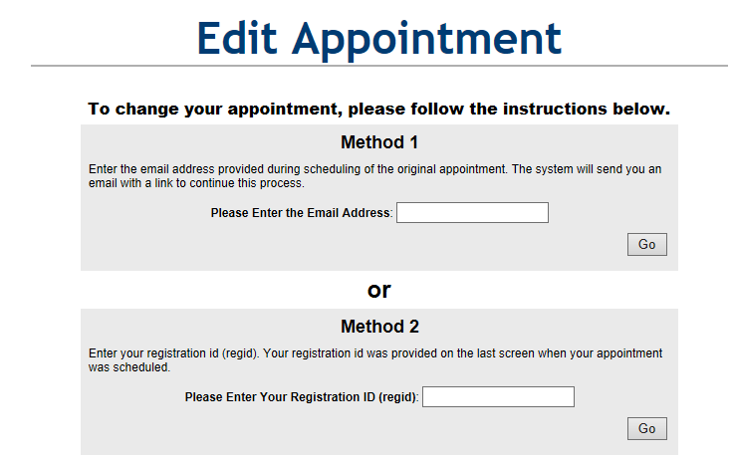

# Cancelling an Appointment

To cancel an appointment, you must call the MorphoTrust Massachusetts Customer Service Center toll free at (866) 349-8130. Before cancelling, you should be certain you do not need an alternate appointment.

# Missed Appointments

If you miss your appointment, you can schedule a new appointment by visiting the MorphoTrust USA IdentoGO™ registration web site and selecting the option to change your existing appointment. The website allows applicants to change appointment locations and times as necessary. Please follow instructions presented on the website. You may also contact the MorphoTrust Massachusetts Customer Service Center at (866) 349-8130 to schedule a new appointment.

If you wish to cancel your appointment completely, please follow the instructions in the Cancelling an Appointment section above.

# Rejection Notification

In some instances, an applicant’s fingerprints are rejected by either the Massachusetts State Police or Federal Bureau of Investigation due to poor fingerprint quality.

If you receive a reject notification, you must do the following:

* Go to <http://www.identogo.com/FP/Massachusetts.aspx>
* Click **I received a rejection notification and need to schedule an appointment** link at the bottom of the page.

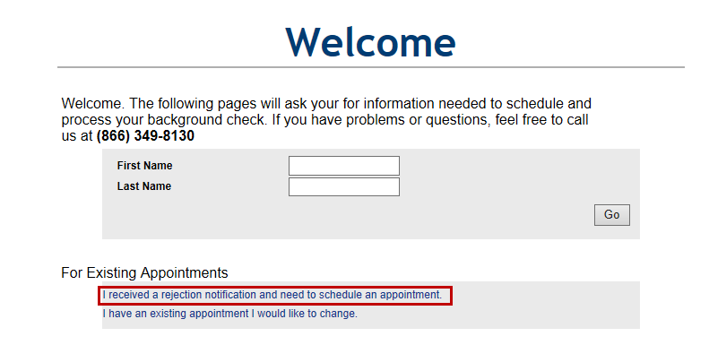

* Enter your **email address**, **Registration ID**, or **Transaction Control Number (TCN)** in one of the boxes provided. Please note the TCN is a unique thirteen (13) character alphanumeric field which is assigned to each civil fingerprint submission and is printed on the receipt provided at the conclusion of the fingerprint appointment. If you do not have the required information, or if the web site does not locate your record, please contact MorphoTrust Massachusetts Customer Service Center at (866) 349-8130 for assistance.
* Click **Go**.

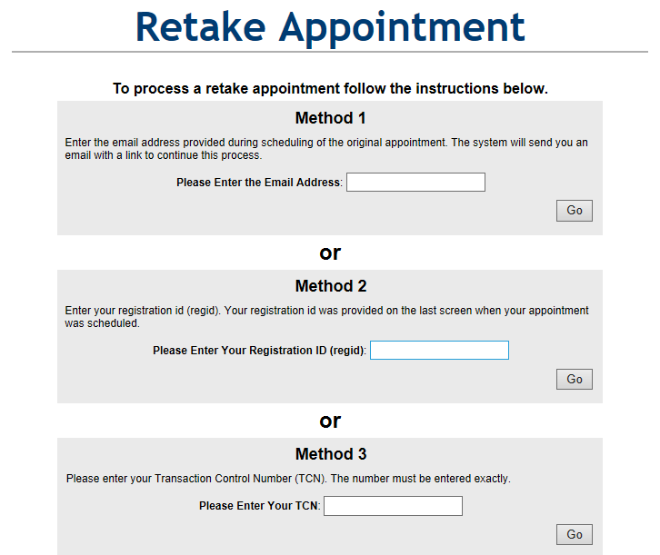

# Acceptable Forms of Identification

All applicants will be required to present an acceptable form of identification at the time of fingerprint capture at a MorphoTrust USA IdentoGO™ Center. Acceptable forms of identification are as follows:

## Primary Identification Documents

The following documents are acceptable forms of identification:

* Driver's License from any U.S. state or territory
* Valid State Identification Card from any U.S. state or territory
* U.S. Passport or U.S. Passport Card
* Permanent Resident Card or Alien Registration Receipt Card (Form I-551)
* Foreign Passport with temporary I-551 stamp or temporary I-551 printed notation on a machine readable immigrant visa
* Foreign Passport and Form I-94 or Form I-94A
* Employment Authorization Document which contains a photograph (Form I-766)
* U.S. Military Card with identifiable photograph.
* U.S. Coast Guard Merchant Mariner Document or Merchant Mariner Credential
* Transportation Worker Identification Credential
* Enhanced Tribal Card

**All documents must include an identifiable photo, the applicant's full name, and date of birth. All documents must be verifiable and unexpired.**

## Applicants Under 18 Years of Age

If you are under eighteen (18) years of age and unable to present one of the primary identification documents listed above, you must provide an original or certified copy of a Birth Certificate issued by an authorized U.S. agency with an official seal or Certification of Birth Abroad (issued by U.S. Department of State) **AND** one of the following documents:

* School Identification Card (Public or Private School)
* School Record or Report Card
* Home Schooling Education Plan
* U.S. Social Security Card

# Fingerprint Appointment

You are expected to visit a MorphoTrust USA IdentoGO™ enrollment center at the scheduled date and time. You should be sure to have all required documentation and identification with you, and should expect the fingerprinting process to take from 5-10 minutes. The Enrollment Agent onsite will verify your identity with the provided identification document, scan your identification to verify authenticity, verify all of your demographic data, and then proceed to fingerprint you using electronic scanning equipment. Any questions prior to or after the fingerprint appointment should be directed to the MorphoTrust Massachusetts Customer Service Center at (866) 349-8130 or to DDS.

At the conclusion of your fingerprint appointment, you will be provided with a receipt. Please provide a copy of the receipt to the DDS Criminal Background Check Unit at 500 Harrison Avenue, Boston, MA 02118. A single receipt will be provided to the applicant; please be sure to retain the copy and make an extra copy for your own files. Multiple copies will not be provided.

# Contacting Customer Service

|  |  |
| --- | --- |
| For assistance with scheduling, rescheduling, or cancelling an appointment, refunds, or directions to a MorphoTrust USA IdentoGO™ enrollment center.  Monday-Friday 7:00 a.m. – 6 p.m. EST | Phone: (866) 349-8130 |
| For assistance with obtaining a status or interpretation of your fingerprint-based criminal history check results. (**NOTE**: Please do not contact DDS until 72 hours has passed since your fingerprints were taken at a MorphoTrust USA IdentoGO™ enrollment center.)  Monday-Friday 9:00 a.m.-5:00 p.m. EST | Phone: (617) 624-7780  Email: dds.nationalbackgroundunit@massmail.ma.us |